Dear Early Years Parents and Carers,  This half term is all about our school value ‘Be Amazed’. Please follow us on twitter @GCPSReception and Seesaw to continue to see your child’s learning.  Best wishes  Ms Leslie | What will my child be learning in the Early Years?  There are three prime areas of learning: Communication and Language Development Personal, Social and Emotional Development Physical Development.  There are four core areas of learning: Literacy; Maths; Understanding the World; Expressive, Arts and Design | In addition, the ‘Characteristics of Effective Learning’ underpin learning and development across all areas and support the child to remain an effective and motivated learner. The Characteristics of Effective Learning are: Playing and exploring- engagement, active learning-motivation, creating and thinking critically-thinking. | 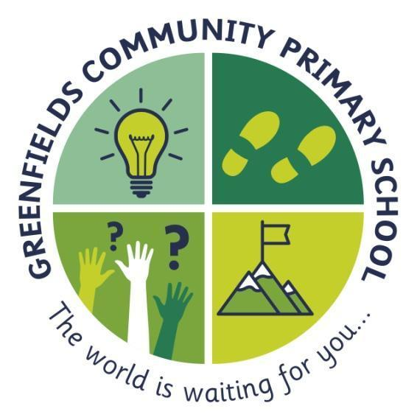  Reception
In Personal, Social and Emotional Development we are learning to:  -practice skills of assertion, negotiation and compromise and show consideration of other people’s needs.  -describe our own likes and dislikes.  -talk about our own and others’ feelings and behaviors and its consequences.  - Know how to engage in positive interactions with adults and peers.  - Play with one or more children, extending and elaborating play ideas | ...be amazed...  ~ stay curious and follow your dreams... never lose your sense of wonder ~  This is shown by the light-bulb; this will remind you to never stop having those ‘light-bulb’ moments. The world is a fascinating place and we never want you to stop being amazed by it. |  | In Communication and Language, we are learning to:  - listen to others 1:1, in small groups and whole class.  - enjoy listening to a range of stories and can remember what happens.  - join in with repeated refrains and anticipate key events and phases in stories or rhymes.  - respond appropriately when asked; e.g., ‘hands up, listen up’  - scaffold play and conversations  - sing nursery rhymes daily.
In Physical Development we are learning to  - handle tools, objects, construction, and malleable materials safely and with increasing control and intention.  - show some understanding that good practices with regards to exercise, eating, drinking water, sleeping and hygiene can contribute to good health.  - develop the overall body strength, co-ordination, balance, and agility needed to engage successfully with future physical education sessions | In Literacy we are learning to:  - be aware of the way stories are structured.  - retell familiar rhymes, stories or poems and complete a repeated refrain.  - use illustrations to help us to understand what is happening in a story.  - to recognise some familiar words in print, e.g., own name or advertising logos.  - develop phonological and phonemic awareness – continuing a rhyming string and identifying alliteration  - hear general sound discrimination and to be able to orally blend and segment.  - Understand that writing and marks communicates meaning.  - to write our name by copying it from a name card or by writing it from memory. | In Maths we are learning to:  - Subitise  - Count objects, counting by rote, counting aloud, clapping, stamping, drumming etc, nursery rhymes, counting songs, using fingers to represent numbers  - Match and sort objects into groups in a variety of ways  - Compare size, mass & capacity – big/little, large/small, short/tall, tallest/shortest.  - Comparing amounts – equal, more than, fewer than.  - Exploring pattern - making simple patterns, odd one out, exploring more complex patterns. | In Understanding the World, we are learning to:  - Identify the members of our immediate family and their relationship to us.  - understand that you can find out information from different sources e.g., internet, books.  - know and talk about the special things in our own lives.  - Know how to show respect and care for the natural environment and all living things.  Know that families in other countries across the world engage in similar activities to our own family and know some differences.  - understand that features of our immediate environment can be represented with objects and on paper e.g., classroom maps.  - describe what we see, hear, and feel outside and know that the environment where we live can change through the seasons.  - Explore the natural world around us by taking part in weekly forest school inspired ‘Nature School’ sessions.  In Expression Art and Design we are learning to:  - grip a pencil comfortably and make marks, create lines and circles.  -sing familiar songs  - use tools for a purpose.  - make music in a range of ways.  - introduce a storyline or narrative into our play.  - create a self-portrait.

