Dear Year 2 Parents and Carers,  This half term is all about our school value ‘Be Amazed’. Please follow us on twitter @GCPSYear2 and make sure you are connected to your child’s seesaw account to continue to see your child’s learning.  Best wishes  Mrs Wilson | In Computing we are learning about;  My Online Life  This activity takes place over the course of the term. It covers all the DFE statutory requirements for digital literacy and online safety. | In RWInc we are;  -Consolidating using and applying set 3 sounds through a daily RWInc session.  In SPaG we are;  -Classifying words, recognising adjectives, nouns, verbs and adverbs  - Developing strategies for spelling, including learning new spelling rules with a greater focus on spelling words correctly. | 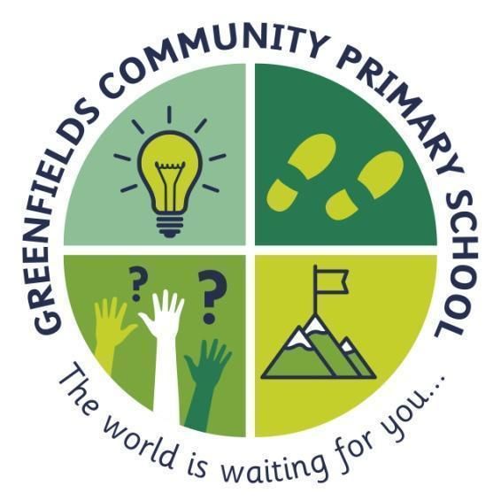  Year 2
In English we are reading;  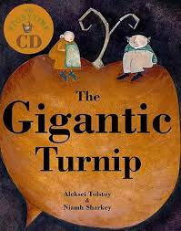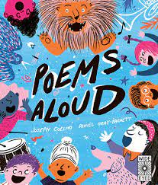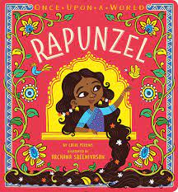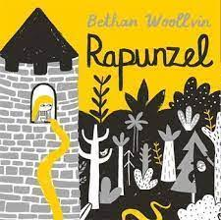  - Developing our stamina for writing; saying the sentence before we write, holding the sentence and writing it using finger gaps and the correct punctuation, editing where appropriate.  - Reading lots; developing a real love of reading. | 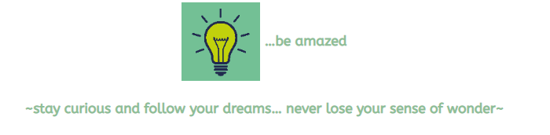  This is shown by the light-bulb; this will remind you to never stop having those ‘light-bulb’ moments. The world is a fascinating place and we never want you to stop being amazed by it. |  | In Maths we are;  -Focusing on place value, within 100  -Counting in 2s, 3s, 5s and 10s to develop pace and fluency  -Learning about fractions  -Learning strategies to add, subtact, divide and multiply with increasing pace
In Science we are learning about; Animals including humans  -Notice that animals, including humans, have offspring which grow into adults  -Find out about and describe the basic needs of animals, including humans, for survival (water, food and air)  -Describe the importance for humans of exercise, eating the right amounts of different types of food, and hygiene | In History we are learning about;  Is it important to remember the consequences of the past?  Our work in history will have a local and regional focus, beginning by thinking about our own memories before moving on to look at remembrance and developing our own understanding about consequences of the past. This will include a visit to the war memorial. | In Art we are:  Drawing - Tell a Story  Using storybook illustration as a stimulus, children develop their mark-making to explore a wider range of tools and experiment with creating texture to add detail to drawings.  Painting and mixed media- Exploring colour mixing and creating a range of secondary colours in paint. Learn about texture, collage and adding detail. | Throughout the rest of the curriculum we are learning;  -PSHE- How to make friends with others  -RE – How should we care for others and why does it matter?  -PE – Perform dances using simple movement patterns

