Dear Year 1 Parents and Carers,  This half term is all about our school value ‘Be Amazed’.  Please follow us on Twitter @GCPSYear1 to continue to see your child’s learning.  Best wishes,  Mrs Armer and Mrs Banks | In Computing we are;  -Thinking about how to stay safe online.  -Understanding which devices we can use  - Identifying ways we communicate online.  -Making animations based on online situations we may encounter.  -Learning how to select and open the correct applications for the task we are completing. | In History we are learning to;  -Understand what chronology means and how it links to our lives.  -Look at the local area and how it has changed over time.  -Think about how we have changed from being a baby to now.  -Talk about how we know if something is old or new.  -Discuss if changes are always a good thing. | 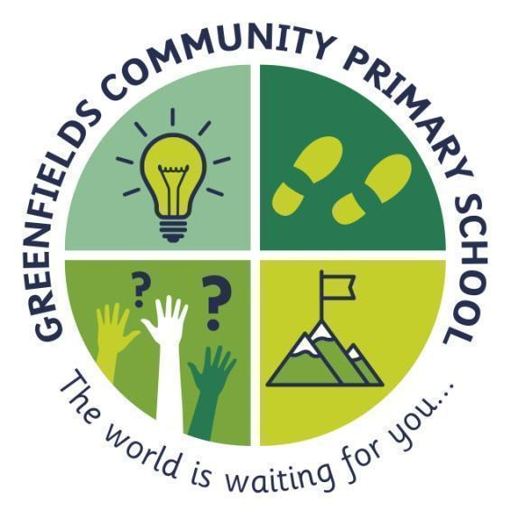  Year 1
In English we will;  - Read some familiar stories including the Gingerbread Man and Little Red Riding Hood.  - Know simple plots of familiar stories off by heart  - Recognise the basic features of familiar stories eg 'good' and 'bad' characters, repetition, good triumphs etc  - Know that instructions have to be clear enough to understand, in the correct order and include all necessary elements.  - Start to identify similarities and differences between their own lives and that of children around the world. | 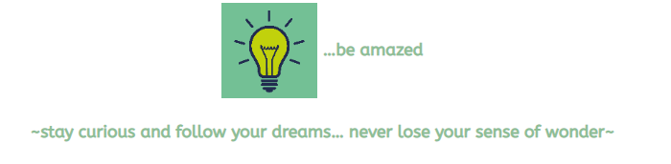  The light-bulb represents the big dreams and the sense of curiosity fostered by introducing our children to the widest of worlds including the most spectacular that the human and natural world has to offer. |  | In Maths we are learning to;  - count to and across 20, forwards and backwards, beginning with 0 or 1, or from any given number  - identify and represent numbers using objects and pictorial representations including the number line, and use the language of: equal to, more than, less than (fewer), most, least  -represent and use number bonds and related subtraction facts within 10  -read, write and interpret mathematical statements involving addition (+), subtraction (−) and equals (=) signs
In Science we are going to be investigating Seasonal Change  We will:  -Observe changes across the 4 seasons  -Observe and describe weather associated with the seasons and how day length varies  - Identify which clothing we would need to wear in each of the 4 seasons | In RE we are learning about;  - What is a Christian and what are their beliefs?  -What important events Christians celebrate.  -What Christians believe about God,  -What the bible tells us about their belief in God.  -Why Jesus is important to Christians. | In Art we are going to refine our drawing and mark making skills  We will be:  - Exploring mark making and line  - Starting our own sketch books to document our work and drawings  -Working and experimenting with different materials through observational and collaborative pieces. | In PSHE we will be;  -Thinking about what we like/dislike and are good at.  -What makes us special and how everyone has different strengths  -How our personal features or qualities are unique.  -How we are similar or different to others.

