Dear Year 4 Parents and Carers,  This half term is all about our school value ‘Be Amazed’. Please follow us on twitter @GCPSYear4 to continue to see your child’s learning.  Best wishes,  Mr Lumsdon | In Computing we are;  - Looking at ‘Real or Fake News’ by evaluating what we see online and identifying whether we can trust it or not  -Describing strategies for safe and fun experiences in a range of  online social environments  -Learning how to be respectful to  others online.  -Understanding the impact technology can have on my health, well-being and lifestyle. | In SPaG we are;  - Identifying and using expanded noun phrases  -Recognising different tenses such as present perfect and comparing this to simple past tense  -Ensuring we recognise the correct use of Standard English, in particular when using ‘was’ or ‘were’  -Recognising the different types of sentence; statement, question, command and exclamation  -Learning our weekly spellings and applying those into our work | 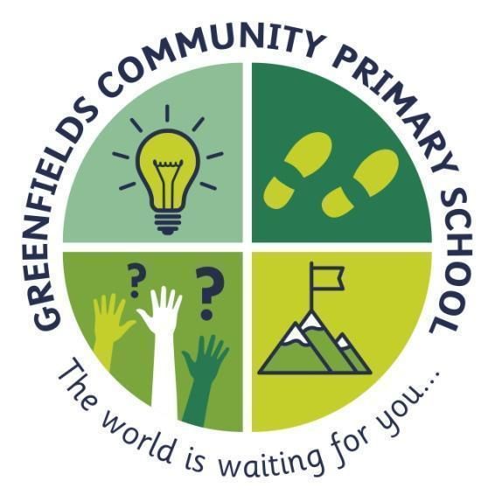  Year 4
In English we will;  - Read the novel Stitch Head by Guy Bass  -Use dictionaries for unfamiliar words  -Draw inferences about characters' feelings and motives and discuss understanding.  -Use the vocabulary, structure and grammar from their reading in their writing.  -Create characters, setting and plot.  -Build rich and varied vocabulary and varied sentence structure. | 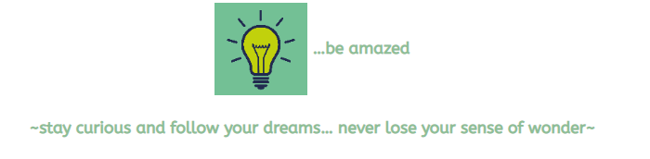  The light-bulb represents the big dreams and the sense of curiosity fostered by introducing our children to the widest of worlds including the most spectacular that the human and natural world has to offer. |  | In Maths we are learning to;  - Read, write, order and compare numbers to at least 1000 and determine the place value of each digit  - Round any number to the nearest 10, 100, and 1000  - Interpret negative numbers in context  - Finding 1000 more and less than a number  -Counting forwards and backwards in multiples of 10, 50 and 100 from any given number  -Solve reasoning and problem-solving questions by applying the skills we have learned.
In Science we are:  Exploring the use classification keys to help group, identify and name a variety of living things in their local and wider environment and recognising that environments can change and that this can sometimes pose dangers to living things. | In History we are learning to;  -Study the period running from the Stone Age through to the Bronze Age.  -Build timelines using accurate scaling to judge duration.  -Understand the limits of prehistoric information. | In Art we are:  -Using tone to create 3D pencil drawings.  -Beginning to show proportion in our artwork.  -Using scissors to explore patterns and symmetry within art.  -Exploring the use of the wax resist technique to experiment with different materials.  -Creating large prints to showcase our skills. | -PSHE -We are looking at our self-esteem: self-worth; personal qualities; goal settings and managing setbacks.  -RE – We are looking at why Jesus is inspiring to many.  -PE –We are developing flexibility, strength, technique, control and balance through gymnastics.  -French - Recapping greetings and numbers.

