Dear Year 6 Parents and Carers,  This half term is all about our school value ‘Be Amazed’. Please follow us on twitter @GCPSYear6 to continue to see your child’s learning.  Best wishes  Miss Evans | In French we are;  -revising basic vocabulary from previous years.  -talking about places within school and different lessons  -learning to express our opinions of different lessons  - using basic conjunctions to join simple sentences | In SPaG we are;  -Revising SPAG from previous year groups to fill in gaps.  -Classifying different word types.  -Using relative clauses beginning with who, which, where, when, whose, that or with an implied (i.e. omitted) relative pronoun  -Understanding the use of different tenses in English.  -Practising using more sophisticated punctuation such as semi-colons. | 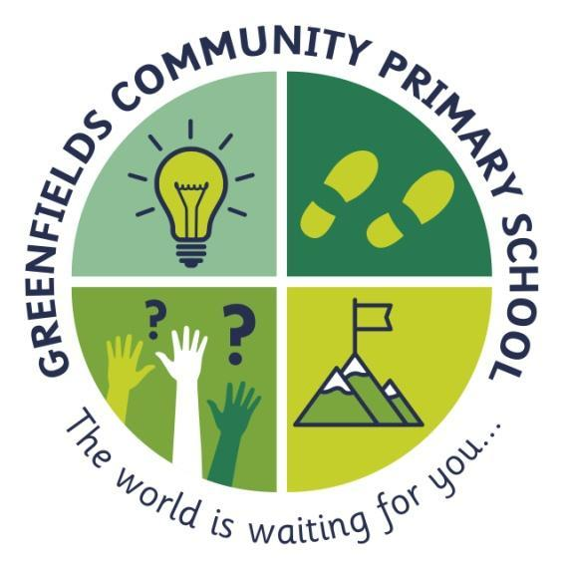  Year 6
In English we are;  -Reading Wild Boy by Rob Lloyd Jones  -Writing a biography of Dr Barnardo focussing on extending sentences in a variety of ways  -using a variety of descriptive techniques in our own narrative writing and understanding how authors experiment with style  -focussing on effective dialogue within narrative  -Reading a selection of fiction, non-fiction and poetry to focus on retrieval and summarising skills. | ...be amazed...  ~ stay curious and follow your dreams... never lose your sense of wonder ~  This is shown by the light-bulb; this will remind you to never stop having those ‘light-bulb’ moments. The world is a fascinating place and we never want you to stop being amazed by it. |  | In Maths we are;  -reading, writing, ordering and comparing numbers up to 10,000,000 and determine the value of each digit  -rounding any whole number to a required degree of accuracy  -using negative numbers in context, and calculating intervals across 0  -Becoming confident with all 4 operations and being able to solve problems involving each or a mixture of them.
In Science we are learning about;  ‘Animals including humans’  -Recap the different systems our body uses such as circulatory, digestive, muscular and skeletal.  -Identify the main components of the circulatory system.  -Describe how the lungs and heart work together.  -Understand how a healthy lifestyle has a positive impact on our circulatory system. | In Art we are learning about;  -symbolism in art and using Mayan art as inspiration  -chiaroscuro and practising this skill with a variety of media  -graffiti styles and developing our own  -using imagery to create a piece of art about something important to the individual child | In History we are learning about;  Ancient civilisations; The Shang Dynasty, Ancient Indus Valley, Ancient Sumer and Ancient Egypt.  -What they have in common and the characteristics and features an Ancient civilisation would have needed to thrive.  -How each civilisation has impacted the modern world that we live in today. | Throughout the rest of the curriculum we are learning;  -PSHE We will be learning about the uses and dangers of different drugs including alcohol  -RE We are exploring what is important to Christians and Humanists eg codes to live by  -PE We will be practising dribbling, passing and blocking skills as well as team tactics though hockey.

