Dear Year 5 Parents and Carers,  This half term is all about our school value ‘Be Amazed’. Please follow us on twitter @GCPSYear5 to continue to see your child’s learning.  Best wishes,  Mr Coverdale and Mrs Bridge | In Computing we are;  - Creating a vlog and learning about what it takes to become a YouTuber.  - Considering the positives and negatives of being a YouTuber and the dangers of having a career online.  - Creating a 3-part vlog on our subject of choice and working as part of a team.  - Using IMovie to record, edit and create a vlog. | In SPaG we are;  - Identifying and using proper nouns.  - Indicating degrees of possibility using adverbs.  - Converting nouns and adjectives into verbs using suffixes.  - Using correct tenses: Past & Present Progressive and Present Perfect  - Using apostrophes of possession with plural nouns  - Using expanded noun phrases (expanded by the addition of modifying adjectives, nouns and prepositional phrases) | 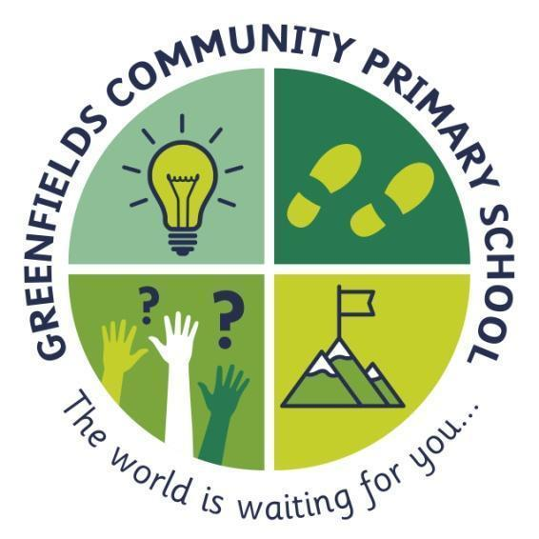  Year 5
In English we will;  - Work out the meaning of words from context.  -Write a biography of a famous artist.  - Read and interpret a non-fiction text.  - Skim and scan fiction and non-fiction texts for meaning.  - Retrieve; record and collate information from a range of texts.  - Summarise information from a text  - Make inferences from a text.  - Write a narrative based on the story Boy in the Tower | 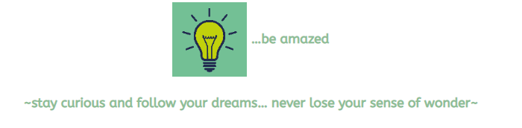  The light-bulb represents the big dreams and the sense of curiosity fostered by introducing our children to the widest of worlds including the most spectacular that the human and natural world has to offer. |  | In Maths we are;  - Reading, writing, ordering and comparing numbers to at least 1 000 000 and determine the place value of each digit  - Rounding any number up to 1 000 000 to the nearest 10, 100, 1 000, 10 000 and 100 000  - Adding and subtracting numbers mentally with increasingly large numbers  - Multiplying and dividing numbers mentally drawing upon known number facts,  - Multiplying numbers up to 4 digits by a one- or two-digit number using a formal written method, including short multiplication and long multiplication for two-digit numbers.
In Science we are:  -Describing the differences in the life cycles of a mammal, an amphibian, an insect and a bird  - Describing the life process of reproduction in some plants and animals  - Recording data and results of increasing complexity using scientific diagrams and labels | In History our question for this half term is;  ‘What did power look like in Ancient history and how would someone achieve it?’  We are learning about the Shang Dynasty. We will be focusing on how advanced they were, where they ruled and for how long. | In Art we are going to:  -Apply confident skills to make an effective collagraph print.  -Independently select tools and drawing techniques, with some guidance.  -Demonstrate growing independence, discussing ways to improve work. | -PSHE - identity personal attributes and qualities; similarities and differences.  -RE – looking at how Jesus influenced the Earth  -PE – Develop flexibility, strength, technique, control and balance  -French - useful phrases, school, music and celebrations, seasons and holidays and food

