Dear Year 3 Parents and Carers,  This half term is all about our school value ‘Be Amazed’. Please follow us on twitter @GCPSYear3 to continue to see your child’s learning.  Best wishes  Mrs Cockman | In French we are learning about:  All About Me  -Introducing yourself and greetings  -Numbers to 10 and giving your age  -Family members  In Computing we are learning about:  Learning how to use the internet to find places, people and other information  Learning how to, and understanding why we need to be safe online | In SPaG we are;  -Classify words, recognising adjectives, nouns, verbs and adverbs  -Revisit capital letters and full stops  -Understand how to use inverted commas  - Learning to spell high frequency words  -Understand prefixes and suffixes  -Recognise and use main clauses and subordinate clauses | 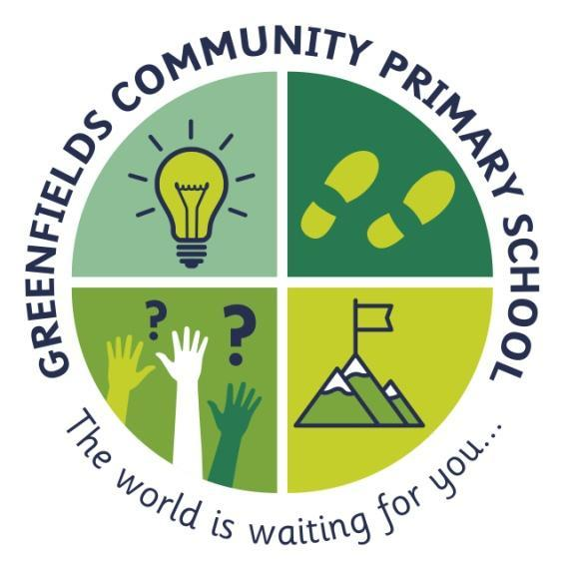  3KC
In English we are;  -Reading ‘Flotsam’ by David Weisner, ‘Please Mrs Butler’ by Allan Allburg and the ‘Accidental Prime Minister’ by Tom McLauglin  - creating instructions on how to look after our environment  -listening and reading poetry, analysing verses and performing  -exploring characters, writing in role  -retrieving information and making inferences | ...be amazed...  ~ stay curious and follow your dreams... never lose your sense of wonder ~  This is shown by the light-bulb; this will remind you to never stop having those ‘light-bulb’ moments. The world is a fascinating place and we never want you to stop being amazed by it. |  | In Maths we are;  -Read, write, compare and order numbers up to 1000  -Recognise the place value of each digit in a three-digit number (hundreds, tens and ones).  -Find 10 or 100 more or less than a given number.  -Know and understand fractions  Add and subtract numbers mentally
In Science we are learning about;  ‘Animals including humans’  -Identify that humans and some other animals have skeletons and muscles for support, protection and movement]  -Identify that animals, including humans, need the right types and amount of nutrition,  -Investigate different food groups  -Investigate how good nutrition and exercise keep us healthy | In Art we are learning to;  Draw- Growing Artists  -Know the difference between organic and geometric shapes.  -Use shading to demonstrate a sense of light and dark in their work.  -Blend tones smoothly and follow the four shading rules.  -Understand how to apply tone, with some guidance about where to use it. | In History we are learning about;  -The Industrial Revolution.  -Use timelines to explore chronology.  -Explore what the Industrial Revolution was and what it meant for all people.  -Discover inventions and what they were used for, finding out how they changed our lives.  -Comparing life in the 1800s to live now. | Throughout the rest of the curriculum we are learning;  -PSHE - How positive friendships support our wellbeing  -RE - What do Christians learn from the Creation story?  -PE - Gymnastics - composing movements to create sequences

