Dear Early Years Parents and Carers,  This half term is all about our school value ‘Be Amazed’. Please follow us on twitter @GCPSNursery, Instagram @muddybairnsgcps and Seesaw to continue to see your child’s learning.  Best wishes,  Miss Ware | What will my child be learning in the Early Years?  There are three prime areas of learning: Communication and Language Development Personal, Social and Emotional Development Physical Development.  There are four core areas of learning: Literacy, Maths, Understanding the World and Expressive Arts and Design | In addition, the ‘Characteristics of Effective Learning’ underpin learning and development across all areas and support the child to remain an effective and motivated learner. The Characteristics of Effective Learning are: Playing and exploring-engagement, Active learning-motivation, Creating and thinking critically-thinking. | 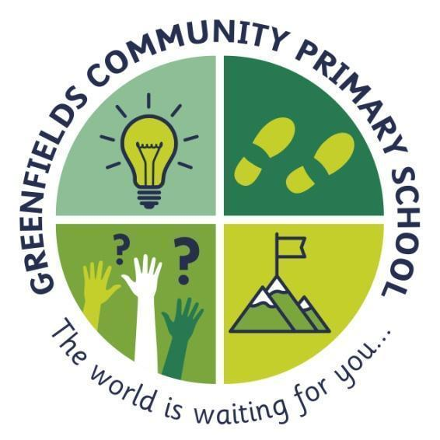  Nursery
In Personal, Social and Emotional Development we are learning to:  - Form a secure bond with a key worker and play in parallel, observing others and copying ideas  - Understand and join in with some familiar routine activities, led by an adult  - Know who to ask for help  - Use different areas and resources safely and appropriately (e.g. that some resources stay in a particular area)  - Follow adult directions to assist in tidying routines  - Be aware of their own physical characteristics  - Select from a small range of resources on offer within a single activity  - Use some resources safely and appropriately  - Recognise when they, others or characters feel happy and sad | ...be amazed...  ~ stay curious and follow your dreams... never lose your sense of wonder ~  This is shown by the light-bulb; this will remind you to never stop having those ‘light-bulb’ moments. The world is a fascinating place and we never want you to stop being amazed by it. |  | In Communication and Language we are learning to:  - Know some nursery rhymes by heart  - Sit still and listen at story time  - Play alongside other children in self-chosen activities  - Choose some of our own activities during ‘free choice’, sometimes with adult support  - Know that ‘who’ refers to a character and ‘where’ to a place when talking about pictures from a story.  - Play alongside an adult, as play is narrated.  - Know colour names and uses accurately  - Join in with favourite rhymes – some lines, words and actions. Imitate hand gestures and anticipate some words and join in with them.  - Begin to ask simple questions.
In Physical development we are learning:  - Some action rhymes  - Names of different movements- jump hop run gallop, and respond by demonstrating (May not be competent)  To drive scooters, bikes and trikes by pushing feet.  - To climb steps or stairs with alternate feet, using a hand or handrail for support.  - To travel by galloping with a leading foot.  - To run safely and at speed in the outdoor space. Kick, Roll, chase and collect a ball.  - To copy some aspects of whole body action rhymes.  Health and self-care the children should:  - Know they need to use the toilet and can ask adults to help them with clothing  - Begin to know about hand hygiene  - Know that we should clean our teeth twice a day  - Develop appropriate independence in going to toilet when needed  - Wash hands with guidance.  - Snip with scissors or snips  - Begin to mark-make with purpose when given adult support  - Take off own coat, with some support  - Take off own shoes | In Literacy we are learning:  - That at story time we try to sit still and listen  - That we handle books carefully  - The names of appropriate features and objects within stories  - To begin to answer who and where questions  - Maintain focus on a short picture book shared with an adult until the end.  Writing  - To make marks on a range of scales with a range of tools and grips.  In Expression Art and Design we are learning to:  -Create with materials and know that we make marks on paper and easel, not walls, furniture etc.  -Make marks with a wide range of tools and grips.  -Explore mark-making with a range of media  -Move while singing/ listening to music  -Be imaginative and expressive  -The names for everyday items in role-play area - e.g. mop, cloth, kettle etc.  -Use props, similar to the items they represent, appropriately, during simple domestic role play.  -Use small world props in short non-verbal narratives and create sound effects and movements | In Maths we are learning:  - That more means ‘lots’ or a bigger number  - To process simple positional vocabulary in the run of child-initiated play.  - To know that round things can roll  - What ‘same’ means knows numbers 1-3 in order when counting  - To compare small sets of objects by processing the language “more” and “more than”.  - To build with blocks of different shapes and sizes and loose parts, making good choices based on their understanding of properties.  - To match pairs to demonstrate a secure grasp of commonality - e.g. by colour or shape Says number names to 5 in songs and rhymes | In Understanding the World we are learning to:  - Be interested in stories about people and animals  - Be interested in photographs of familiar people  - Investigate materials by using senses  - Understand that materials and objects must not be put in mouth, ears etc.  - That we take care of living things  - Follow adult prompts to explore simple sensory properties of everyday materials and demonstrate engagement facially or through body language.  - Engage in joint attention with adults for short periods of time in respectful observations of living things.  - Transport materials safely and appropriately (eg sand, water, toys in play)  - Actively collect and enjoy transporting materials.  - Sustain interest in action and reaction toys.

