In Music we are learning:  - How to analyse features within different pieces of music, including pitch, volume, tempo and rhythm. | CURRICULUM OVERVIEW  Key Stage 2 – Year 6  Autumn 1...be amazed... | 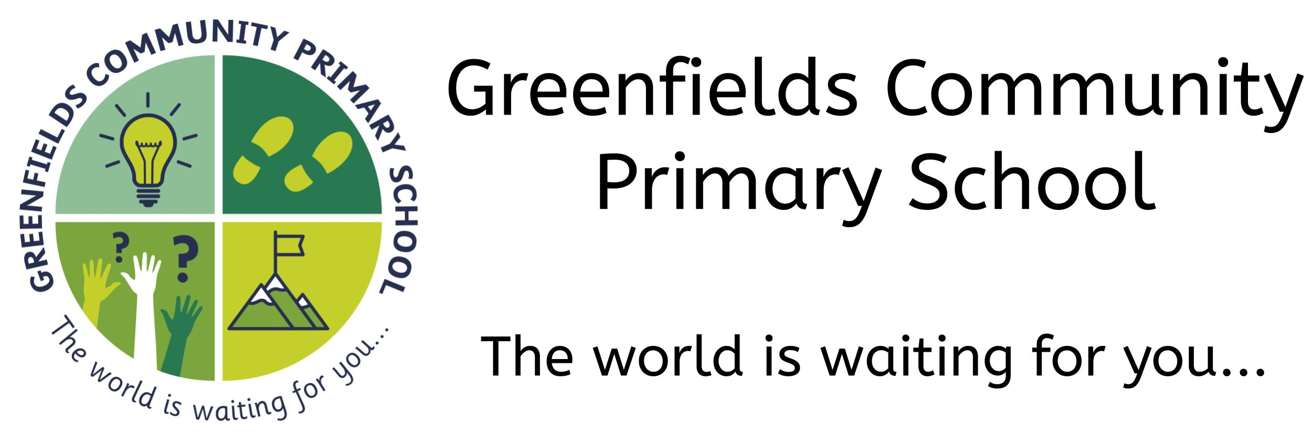
In Art we are learning:
- To explain why different tools have been used to create art
- To explain why chosen specific techniques have been used know how to use feedback to make amendments and improvement to art
 | In P.S.H.E we are learning:  - To recognise their worth as individuals, by identifying positive things about themselves and their achievements  - To see our mistakes, make amends and set personal goals;  - Why and how rules and laws are made and enforced, why different rules are needed in different situations and how to take part in making and changing rules  - Know that there are different kinds of responsibilities, rights and duties at home, at school and in the community | In the Outdoors we are learning:  - To connect with nature and recognise the importance of looking after our environment and the living things that inhabit it  - To participate in scavenger hunts, leaving clues for someone else to follow  - To participate in discussion time, reflecting on our experiences and expressing opinions  - To work on our communication and team-building skills, by co-operating with each other, using the language of negotiation and compromise.
In Modern Foreign Languages we are learning:
- To hold a simple conversation with at least 4 exchanges, firstly revising greetings and basic conversation and moving onto locating places in a town or city
In Design Technology we are learning:
- To recognise which tool to use for a specific practical task
- How to use any tool correctly and safely
- What each tool is used for
- To explain why a specific tool is best for a specific action
In Science we are learning:
- To identify and name the main parts of the human circulatory system, and describe the functions of the heart, blood vessels and blood
- To recognise the impact of diet, exercise, drugs and lifestyle on the way their bodies function
- To describe the ways in which nutrients and water are transported within animals,

In History we are learning:
- Where the Vikings originated from.
- That the Vikings and Anglo Saxons were often in conflict.
- Why the Vikings frequently won battles with the Anglo Saxons

In Computing we are learning:

- To be increasingly aware of the potential dangers in using aspects of IT
- To know when to alert someone if feeling uncomfortable
- To be aware that some search engines may provide misleading information
Our visits and experiences:

- A trip to Craster, where we will walk along the coast to Dustanburgh castle

- A sponsored walk around the local area

- The chance to be a value ambassador and apply to be a lead value ambassador
In Geography we are learning:

- To use maps to locate countries and places of interest
In Religious Education we are learning:
- Research and summarise the religious diversity in the local area.
- Make comparisons between the beliefs and practices of local religious communities. (focus study)
- Reflect on the importance of religious diversity and tolerance.
In P.E. we are learning:
- To combine own work with that of others
- To create sequences to specific timings

