In Music we are learning:  - About music that is linked to our rainforest topic and how different instruments can be used to create it | CURRICULUM OVERVIEW  Key Stage 2 – Year 5  Autumn 1...be amazed... | 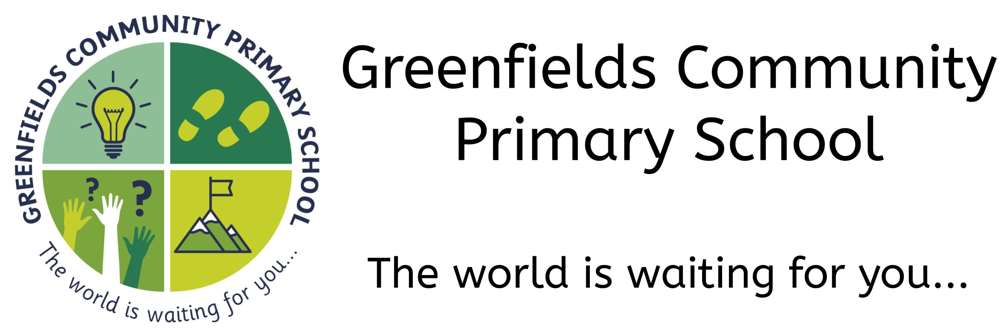
In Art we are learning:
- To research the work of an artist and use their work to replicate a style
- About the work of Abel Rodriguez
- To experiment by using marks and lines to produce texture
- To experiment with shading to create mood and feeling
- How to use shading to create mood and feeling
 | In Design Technology we are learning:  - Know which season various foods are available for harvesting | In History we are learning:  - How attitudes towards the rainforests have changed
In Modern Foreign Languages we are learning:  - To describing ourselves, our bodies and our health  - To hold a simple conversation with at least 4 exchanges  - Use knowledge of grammar to speak correctly  - Understand a short story or factual text and note the main points  - Use the context to work out unfamiliar words  - Write a paragraph of 4-5 sentences  - Substitute words and phrases |  | In Science we are learning:  - About the topic of ‘Living things and their habitats’  - To describe life cycles in insects, birds, mammals and amphibians  - To describe the process of reproduction in plants and animals
In Computing we are learning:
- About staying safe online
- To develop a program that has specific variables identified
 | In P.E. we are learning:  - About Gymnastics and general fitness  - To make complex extended sequences  - To combine action, balance and shape  - To perform consistently to different audiences | In Religious Education we are learning:  - About religious diversity in our local area  - To explain what it means for a religion to have different denominations.  - To compare different denominations in Christianity  - To identify and describe the different Christian communities in the local area
In PSHE we are learning:
- About ‘New Beginnings’
- To be caring and maintain friendships
- To re-establish our school community
- To talk about our mental health and wellbeing
In the Outdoors we are learning:
- About Living things and habitats
- How to identify trees, leaves and branches
- About the life cycle of plants and will be dissecting flowers.
- To explore habitats in our own outdoor space
- How to create obstacle courses with a focus on balance, action and shape

Our visits and experiences:

- A sponsored walk around the local area
- An extra-curricular activity club every Monday after school
- A trip to a National Trust site, such as Gibside.

In Geography we are learning:
- To use maps to identify the location of Saxon settlements

