In Music we are learning:  - To use notation to record compositions in a small group or individually | CURRICULUM OVERVIEW  Key Stage 2 – Year 4  Autumn 1...be amazed... | 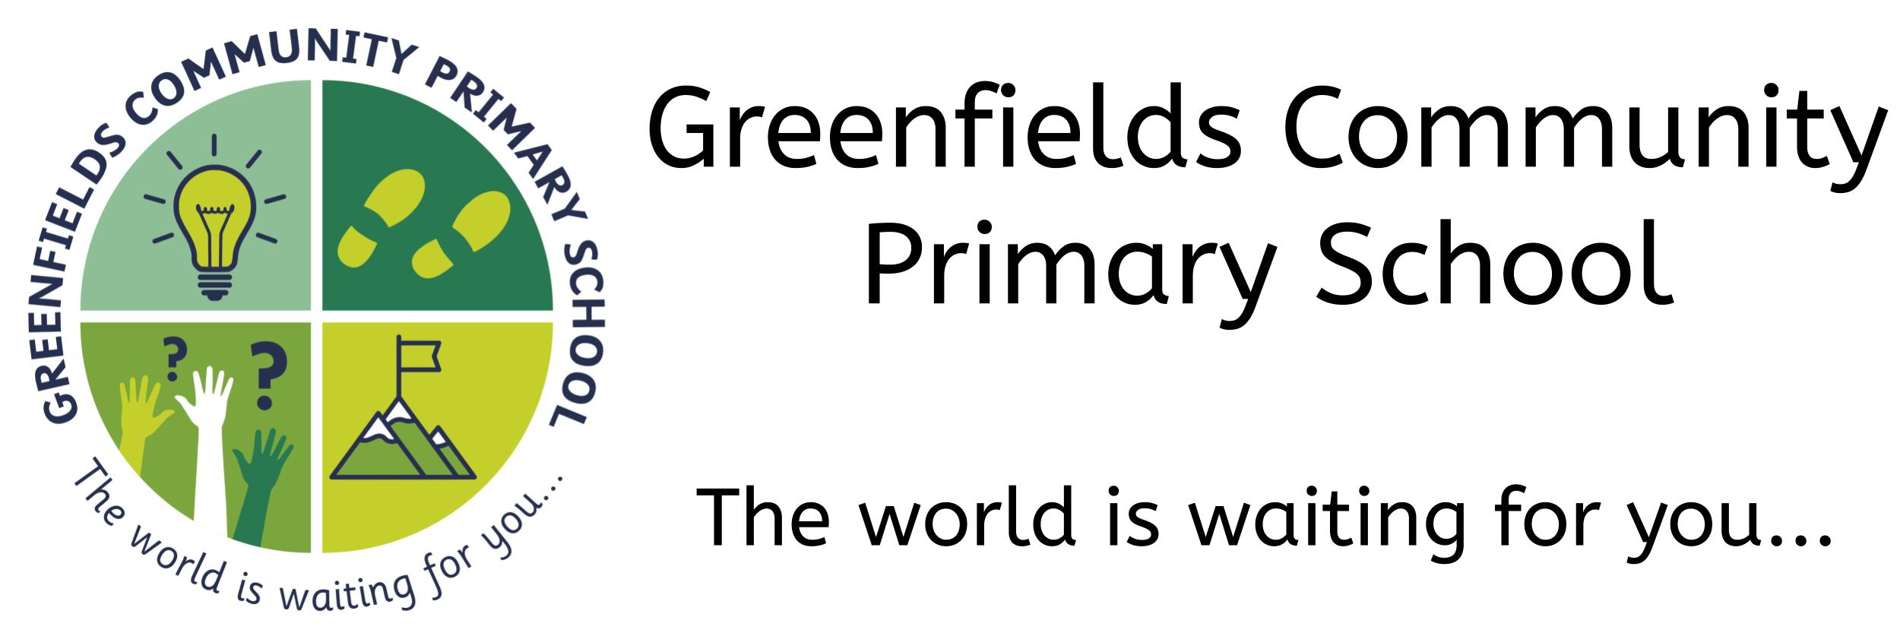
In Art we are learning:
- How to integrate digital images into artwork.
- To use sketchbooks to help create facial expressions
- To use sketchbooks to experiment with different texture
- How to show facial expressions and body language in sketches and paintings

 | In Design Technology we are learning:  - To produce a plan and explain it  - To communicate ideas in a range of ways, including by sketches and drawings which are annotated  - Which tools to use for a particular task and show knowledge of handling the tool  - Which material is likely to give the best outcome  - To measure accurately | In History we are learning:  - About, and naming, some of the advanced societies that were in the world around 3000 years ago  - About the key features of Ancient Egypt
In Modern Foreign Languages we are learning:
- To name and describe people, a place and an object
- To give response using a short phrase
- To explain the main points in a short passage

In PSHE we are learning:  - About ‘New Beginnings’  - To be able to talk about the return to school in a positive way  - To recognise how to deal with change |  | In Science we are learning:  - Recognise living things can be grouped in a variety of ways  - To explore and use classification keys to group, identify and name a variety of living things in their local environment  - To recognise that environments can change and this can pose a danger to living things
In Computing we are learning:

- recognise acceptable and unacceptable behaviour using technology
- give an ‘on-screen’ robot specific instructions that takes them from A to B
- experiment with variables to control models
In Geography we are learning:
- About, and labelling, the main features of a river
- The names of and locations of a number of the world’s longest rivers
- The names of a number of the world’s highest mountains
- To explain the features of a water cycle

 | In P.E. we are learning:  - To compete in athletics  - To sprint over a short distance and show stamina when running over a long distance  - To jump in different ways | Our visits and experiences:  - A sponsored walk around the local area  - An extra-curricular activity club every Monday after school  - A trip to Hadrian’s Wall
In Religious Education we are learning:
- Ask questions about stories about Moses
- Discuss Moses’ life and describe him
- Explain what Moses did for Jewish people and give my opinion on why this is important
In the Outdoors we are learning:
- About animals and their habitats
- Observing the changing seasons from Autumn to Winter
- To participate in outdoor scavenger hunts
- How to use grid references
- To use the orienteering maps that have been done for Forest School
- How to improve our own outdoor area

