In Art we are learning:  - Know how to use sketches to produce a final piece of art  - Know how to identify the techniques used by different artists  - Know how to compare the work of different artists  - Know how to show facial expressions in art | CURRICULUM OVERVIEW  Key Stage 2 – Year 3  Autumn 1...be amazed... | 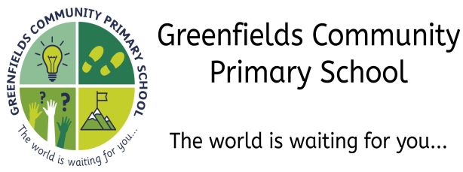
In Modern Foreign Languages we are learning:  - Name and describe people, a place and an object  - Have a short conversation, saying 3 to 4 things  - Give response using a short phrase  - Start to speak, using a full sentence  - Read and understand a short passage using familiar language  - Explain the main points in a short passage  - Read a passage independently  - Use a bilingual dictionary or glossary to look up new words  - Write phrases from memory  - Write 2-3 short sentences on a familiar topic |  | In History we are learning:  - About Greek life and influence on the Western world  - About some of the main characteristics of the Athenians and the Spartans  - About the influence the gods had on Ancient Greece  - Know at least five sports from the Ancient Greek Olympics
In Design Technology we are learning:
- Describe how food ingredients come together- Weigh out ingredients and follow a given recipe to create a dish
- Talk about which food is healthy and which food is not
- Know when food is ready for harvesting
In Science we are learning to:
- Identify that animals, including humans, need the right types and amount of nutrition, and that they cannot make their own food; they get nutrition from what they eat
- Identify that humans and some other animals have skeletons and muscles for support, protection and movement.
In P.E. we are learning to:
- Improvise freely and translate ideas from a stimulus in order to create phrases with a partner or group
- Remember and repeat dance phrases
- Adapt sequences to suit different types of apparatus and criteria
- Explain how strength and suppleness affect performance
In PSHE we are learning:
- About ‘New Beginnings’
- To recognise how to deal with change
In Geography we are learning:  - Know the names of and locate at least eight European countries  - Know at least five differences between living in the UK and a Mediterranean country  - Use maps to locate European countries and capita |  | In Music we are learning to  - Combine different sounds to create a specific mood or feeling  - Create repeated patterns with different instruments  - Improve our work, explaining how it has been improved  - Recognise the work of at least one famous composer
In Computing we are learning:
- recognise acceptable and unacceptable behaviour using technology
In the Outdoors we are learning:

- To participate in scavenger hunts linked to our Maths topic of Place Value – hunting for numbers and going on treasure hunts
- About small animal homes and making some of our own in the Forest School area
Our visits and experiences:

- A trip to the Angel of the North

- A sponsored walk around the local area

In Religious Education we are learning:
- What do Hindus believe and how does it affect the way they live?
- Discuss how our beliefs and values affect how we live.
- Identify different beliefs in Hinduism.
- Explain the significance and impact of Hindu beliefs

