In Art we are learning:  - How to mix paint to create all the secondary colours.  - How to create brown with paint.  - How to create tints with paint by adding white and know how to create tones with paint by adding black | CURRICULUM OVERVIEW  Key Stage 1 – Year 2  Autumn 1...be amazed... | 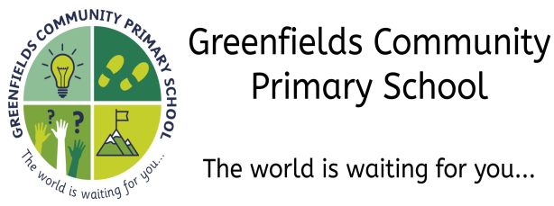
In PSHE we are learning to:  - Recognise that they belong to various groups and communities, such as family and school.  - Recognise how others and feeling and know how to make them better.  - To understand ways which can help me calm down.  - Know how to make someone feel welcomed.  - To work together to make a law. |  | In History we are learning:  - About an event or events that happened long ago, even before our grandparents were born.  - How the local area is different to the way it used to be a long time ago.
In Design Technology we are learning to:
- Join materials and components in different ways.
- Measure materials to use in a model or structure.
- Make a model stronger and more stable.
In Science we are learning to:
- Notice that animals including humans have offspring
- Find out about the basic needs of animals for survival
- Describe the importance of exercise, diet, food and hygiene.

In P.E. we are learning to:
- Change rhythm, speed, level and direction in dance
- Make a sequence by linking sections together
- Use dance to show a mood or feeling
In Modern Foreign Languages we are learning:
- How to say ‘Hello’ and ‘Goodbye’ in French
In Geography we are learning to:  - Identify the following physical features: mountain, lake, island, valley, river, cliff, forest and beach.  - Recognise the names of and locate the five oceans of the world |  | In Music we are learning to:  - Perform simple patterns and accompaniments keeping a steady pulse.  - Play simple rhythmic patterns on an instrument.
In Computing we are learning to:
- Understand that programs require precise instructions.
- Know how technology is used in school and outside of school.
In Religious Education we are learning:  - About Bible creation stories  - Retell a story from the Bible and discuss the message  - To explain what a sacred text is and how they are looked after.  - To compare the Bible with another sacred text. | In the Outdoors we are learning:  - About the rules and boundaries for working outside in the Outdoor Areas  - Look at the nature around us and begin to identify different trees by looking at the twigs, bark and leaves
Our visits and experiences:

- A trip to the Newcastle/Gateshead Quayside

- A sponsored walk around the local area

