In Art we are learning:  - Know how to show how people feel in paintings and drawings. - Describe what can be seen and give an opinion about the work of an artist  - Ask questions about a piece of art | CURRICULUM OVERVIEW  Key Stage 1 – Year 1  Autumn 1...be amazed... | 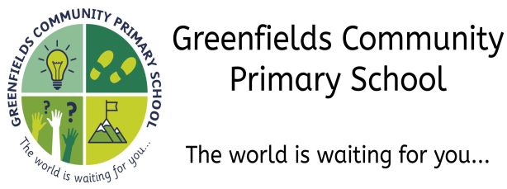
In Design Technology we are learning to:  - Use own ideas to design something and describe how their own idea works  - Explain to someone else how they want to make their product and make a simple plan before making.  - Use own ideas to make something.  - Choose appropriate resources and tools  - Make their own model stronger |  | In History we are learning:  - About George Stephenson/Robert Stephenson  - The name of a famous person, or a famous place, close to where they live  - What a number of older objects were used for
In PSHE we are learning to:

- To recognise what they like and dislike, what is fair and unfair, and what is right and wrong
In Science we are learning to:

- Observe changes across the four seasons

- Observe and describe weather associated with the four seasons and how day length varies

In P.E. we are learning to:
- Make our body curled, tense, stretched and relaxed
- Control body when travelling and balancing
- Copy sequences and repeat them - Roll, curl, travel and balance in different ways
In Modern Foreign Languages we are learning:
- How to say ‘Hello’ and ‘Goodbye’ in French
In Geography we are learning to:  - Know which is the hottest and coldest season in the UK  - Know and recognise main weather symbols |  | In Music we are learning to:  - Use instruments to perform and choose sounds to represent different things  - Follow instructions about when to play and sing
In Computing we are learning to:
- Create a series of instructions and plan a journey for a programmable toy
In Religious Education we are learning:  - Explore what it means to believe.  - Discuss the beliefs of Christianity.  - Ask questions about a religious story. | In the Outdoors we are learning:  - To make an assault course and give directions  - To look for signs of Autumn, collect natural materials and make a seasons collage.  - To make wind and rain gauges  - Make and test water wheels
Our visits and experiences:

- A trip to the Rising Sun Country Park

- A sponsored walk around the local area

