* Describe Moses and discuss his life story

In **Year 4:**

* Ask questions about stories of Mases’ life
* Explain what Moses did for the Jewish people and give opinions on why that is important
* Research and summarise the religious diversity in the local area
* Make comparisons between the beliefs and practices of local religious communities. (focus study)

In **Year 6**:

* Reflect on the importance of religious diversity and tolerance

In **Year 3:**

* Know what Hindus believe and how it affects the way they life
* Discuss our beliefs and values and how they affect how we live
* Explain the significance and impact of Hindu beliefs on peoples’ lives
* Identify the different beliefs in the Hindu religion

In **Year 2:**

* Retell a story from the Bible and discuss the message
* Explain what a sacred text is and how they are looked after.
* Read some of the Bible creation stories
* Compare the Bible with another sacred text
* Ask questions about a religious story

In **Year 1:**

* Explore what it means to believe
* Discuss the beliefs of Christianity

**CURRICULUM OVERVIEW**

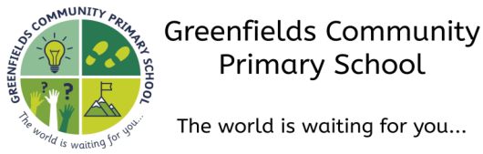

**Autumn 1...be amazed...**

**Subject:** Religious Education

* Compare different denominations in Christianity
* Identify and describe the different Christian communities in the local area

In **Year 5:**

* Understand what we can learn about diversity in our local area
* Explain what it means to have different denominations in a religion

**How this document is structured:**

In case of a bubble or school closure, each box is divided into two sections

–**offline (in-school) and online (remote)**

Subject leaders have identified the knowledge, skills and understanding that can be covered remotely, with a focus on lower order procedural/fluency content. Higher order learning will be delivered at school. In the event of a full school closure, higher order learning will be delivered via pre-recorded videos.

Where there are no school or bubble closures, all objectives will be covered in school.

In **Early Years**, our learning about religious communities is covered through the different areas in our Early Years Framework, in particular ‘**Understanding the World’**.

**In Pre-School,** children are encouraged to notice differences between people and adults model positive attitudes towards differences.

**In Nursery,** children continue to develop positive attitudes about the differences between people, as they are exposed to the diversity of life in Modern Britain.

**In Reception,** children understand that some places are special to members of their community and will start to name and explain the purpose of places of worship and places of local importance to the community.