* Identify where the Anglo Saxons and Vikings came from and why
* Know that the Vikings and Anglo Saxons were often in conflict

In **Year 6**:

* Know where the Vikings originated from and why they invaded Britain
* Know why the Vikings frequently won battles with the Anglo Saxons
* Research some of the civilisations that used to reside in the rainforest

In **Year 5:**

* Linked to curriculum topic of rainforests
* Know about the key features of either:

Ancient Egypt, Ancient Summer, Indus Valley or the Shang Dynasty

In **Year 4:**

* Know about, and name, some of the advanced societies that were in the world around 3000 years ago
* Know some of the main characteristics of the Athenians and the Spartans
* Know at least five sports from the Ancient Greek Olympics

In **Year 3:**

* Know about Greek life and the influence on the Western world
* Know about the influence the gods had on Ancient Greece

In **Year 2:**

* Know about an event or events that happened long ago, even before their grandparents were born
* Know how the local area is different to the way it used to be a long time ago

In **Early Years**, our historical knowledge & understanding is covered through the different areas in our Early Years Framework, in particular through **“Understanding the World”**

**In Pre-School,** children start to make connections between the features of their family and other families and notice differences between people.

**In Nursery,** children start to make sense of their own life-story and family’s history.

**In Reception,** children talk about members of their immediate family and describe people who are familiar to them. They comment on images of familiar situations in the past. They begin to compare and contrast characters, including figures from the past.

In **Year 1:**

* Know what a number of older objects were used for
* Know the name of a famous person, or famous place, close to where they live

**CURRICULUM OVERVIEW**

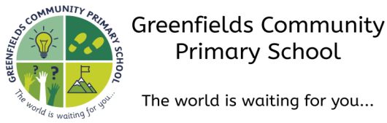

**Autumn 1...be amazed...**

**Subject:** History

**How this document is structured:**

In case of a bubble or school closure, each box is divided into two sections

–**offline (in-school) and online (remote)**

Subject leaders have identified the knowledge, skills and understanding that can be covered remotely, with a focus on lower order procedural/fluency content. Higher order learning will be delivered at school. In the event of a full school closure, higher order learning will be delivered via pre-recorded videos.

Where there are no school or bubble closures, all objectives will be covered in school.