* Know and label the main features of a river
* Know the name of and locate a number of the world’s longest rivers
* Know the names of a number of the world’s highest mountains

In **Year 4:**

* Explain the features of a water cycle
* Know the names of and locate at least eight European countries

In **Year 3:**

* Know at least five differences between living in the UK and a Mediterranean country
* Use maps to locate European countries and capitals

**CURRICULUM OVERVIEW**

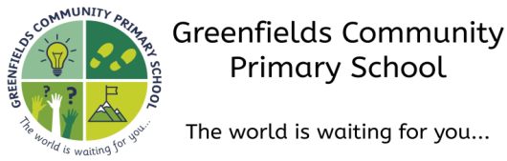

**Autumn 1...be amazed...**

**Subject:** Geography

* Using Google maps to locate countries and places of interest
* Label layers of a rainforest and know what deforestation is

In **Year 5:**

* Know what is meant by biomes and what are the features of a specific biome
* Know how to use graphs to record features such as temperature or rainfall across the world
* Know the names of and locate the five oceans of the world.

In **Year 6**:

* Use maps, atlases, Ordnance Survey maps and aerial photographs to locate countries and places of interest
* Know which is the hottest and coldest season in the UK
* Know and recognise main weather symbols

In **Year 2:**

* Identify the following physical features: mountain, lake, island, valley, river, cliff, forest and beach

In **Year 1:**

* Know how, why and when weather changes

**How this document is structured:**

In case of a bubble or school closure, each box is divided into two sections

–**offline (in-school) and online (remote)**

Subject leaders have identified the knowledge, skills and understanding that can be covered remotely, with a focus on lower order procedural/fluency content. Higher order learning will be delivered at school. In the event of a full school closure, higher order learning will be delivered via pre-recorded videos.

Where there are no school or bubble closures, all objectives will be covered in school.

In **Early Years**, our geographical knowledge is covered through the different areas in our Early Years Framework, in particular ‘**Understanding the World’**.

**In Pre-School,** children begin to explore and respond to different natural phenomena in their setting.

**In Nursery,** children begin to use their senses in hands-on exploration of natural materials and talk about what they can see using a wider vocabulary. They will also know that there are different countries in the world.

**In Reception,** children understand the effect of the changing seasons on the natural world around them, including weather. They will also be able to draw information from a simple map.