* Know what each tool is used for
* Explain why a specific tool is best for a specific action

In **Year 6**:

* Know which tool to use for a specific practical task
* Know how to use any tool correctly and safely
* Sort food into which season it would be planted, grown and harvested

In **Year 5:**

* Know which season various foods are available for harvesting

In **Year 3:**

* Describe how food ingredients come together
* Weigh out ingredients and follow a given recipe to create a dish
* Talk about which food is healthy and which food is not
* Know when food is ready for harvesting

In **Year 4:**

* Know which tools to use for a particular task and show knowledge of handling the tool
* Know which material is likely to give the best outcome
* Measure accurately
* Produce a plan and explain it
* Communicate ideas in a range of ways, including by sketches and drawings which are annotated
* Make a model stronger and more stable.

In **Year 2:**

* Join materials and components in different ways.
* Measure materials to use in a model or structure
* Use own ideas to design something and describe how their own idea works.
* Explain to someone else how they want to make their product and make a simple plan before making

In **Year 1:**

* Use own ideas to make something
* Choose appropriate resources and tools
* Make their own model stronger

**CURRICULUM OVERVIEW**

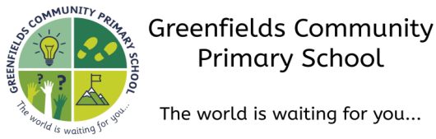

**Autumn 1...be amazed...**

**Subject:** Design Technology

**How this document is structured:**

In case of a bubble or school closure, each box is divided into two sections

–**offline (in-school) and online (remote)**

Subject leaders have identified the knowledge, skills and understanding that can be covered remotely, with a focus on lower order procedural/fluency content. Higher order learning will be delivered at school. In the event of a full school closure, higher order learning will be delivered via pre-recorded videos.

Where there are no school or bubble closures, all objectives will be covered in school.

In **Early Years**, our learning about design & technology is covered through the different areas in our Early Years Framework, in particular ‘**Understanding the World’**.

**In Pre-School,** children begin to explore materials with different properties during their open-ended play. Different textures are offered for exploration.

**In Nursery,** children explore collections of materials with similar and different properties, including natural materials. Children will be introduced to observation and investigation.

**In Reception,** children begin to refine and build on previous learning, refining ideas. They will explore how things work and show interest in different occupations.