* Know how to integrate digital images into artwork
* Know how to show facial expressions and body language in sketches and paintings

In **Year 4:**

* Use sketchbooks to help create facial expressions
* Use sketchbooks to experiment with different texture
* Know how to compare the work of different artists
* Know how to show facial expressions in art

In **Year 3:**

* Know how to use sketches to produce a final piece of art
* Known how to identify the techniques used by different artists

In **Year 5:**

* Experiment with shading to create mood and feeling
* Research the work of an artist and use their work to replicate a style
* Experiment by using marks and lines to produce texture
* Know how to use shading to create feeling

In **Year 6**:

* Explain why specific techniques have been used or chosen
* Know how to use feedback to make amendments and improvements to art
* Explain why different tools have been used to create art
* Give opinion or feedback on a piece of art

In **Year 2:**

* Know how to mix paint to create all of the secondary colours
* Know how to create brown with paint
* Known how to create tints with paint
* Identify the primary and secondary colours
* Describe what can be seen and give an opinion about the work of an artist
* Ask questions about a piece of art

In **Year 1:**

* Know how to show how people feel in paintings and drawings

**CURRICULUM OVERVIEW**

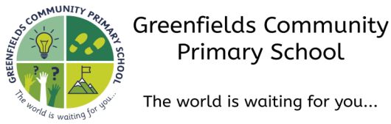

**Autumn 1...be amazed...**

**Subject:** Art

**How this document is structured:**

In case of a bubble or school closure, each box is divided into two sections

–**offline (in-school) and online (remote)**

Subject leaders have identified the knowledge, skills and understanding that can be covered remotely, with a focus on lower order procedural/fluency content. Higher order learning will be delivered at school. In the event of a full school closure, higher order learning will be delivered via pre-recorded videos.

Where there are no school or bubble closures, all objectives will be covered in school.

In **Early Years**, our art and creative education is covered through the different areas in our Early Years Framework, in particular through the ‘**Expressive arts and design”** strand

**In Pre-School,** children start to make marks intentionally, exploring paint using their fingers as well as brushes.

**In Nursery,** children start to draw with increasingly complex detail. They also explore colour and colour mixing and begin to show emotions in their drawings.

**In Reception,** children explore, use and refine a variety of artistic effects to express their ideas and feelings. They may decide to create collaboratively, sharing ideas, resources and skills.