As MUSICIANS we will be...analysing features of different types of music. At home you could:  - Listen to different styles of music or music from different time periods and say what you like or don’t like and why. Compare this with music that other people in your family like to listen to. Is it the same or different? | 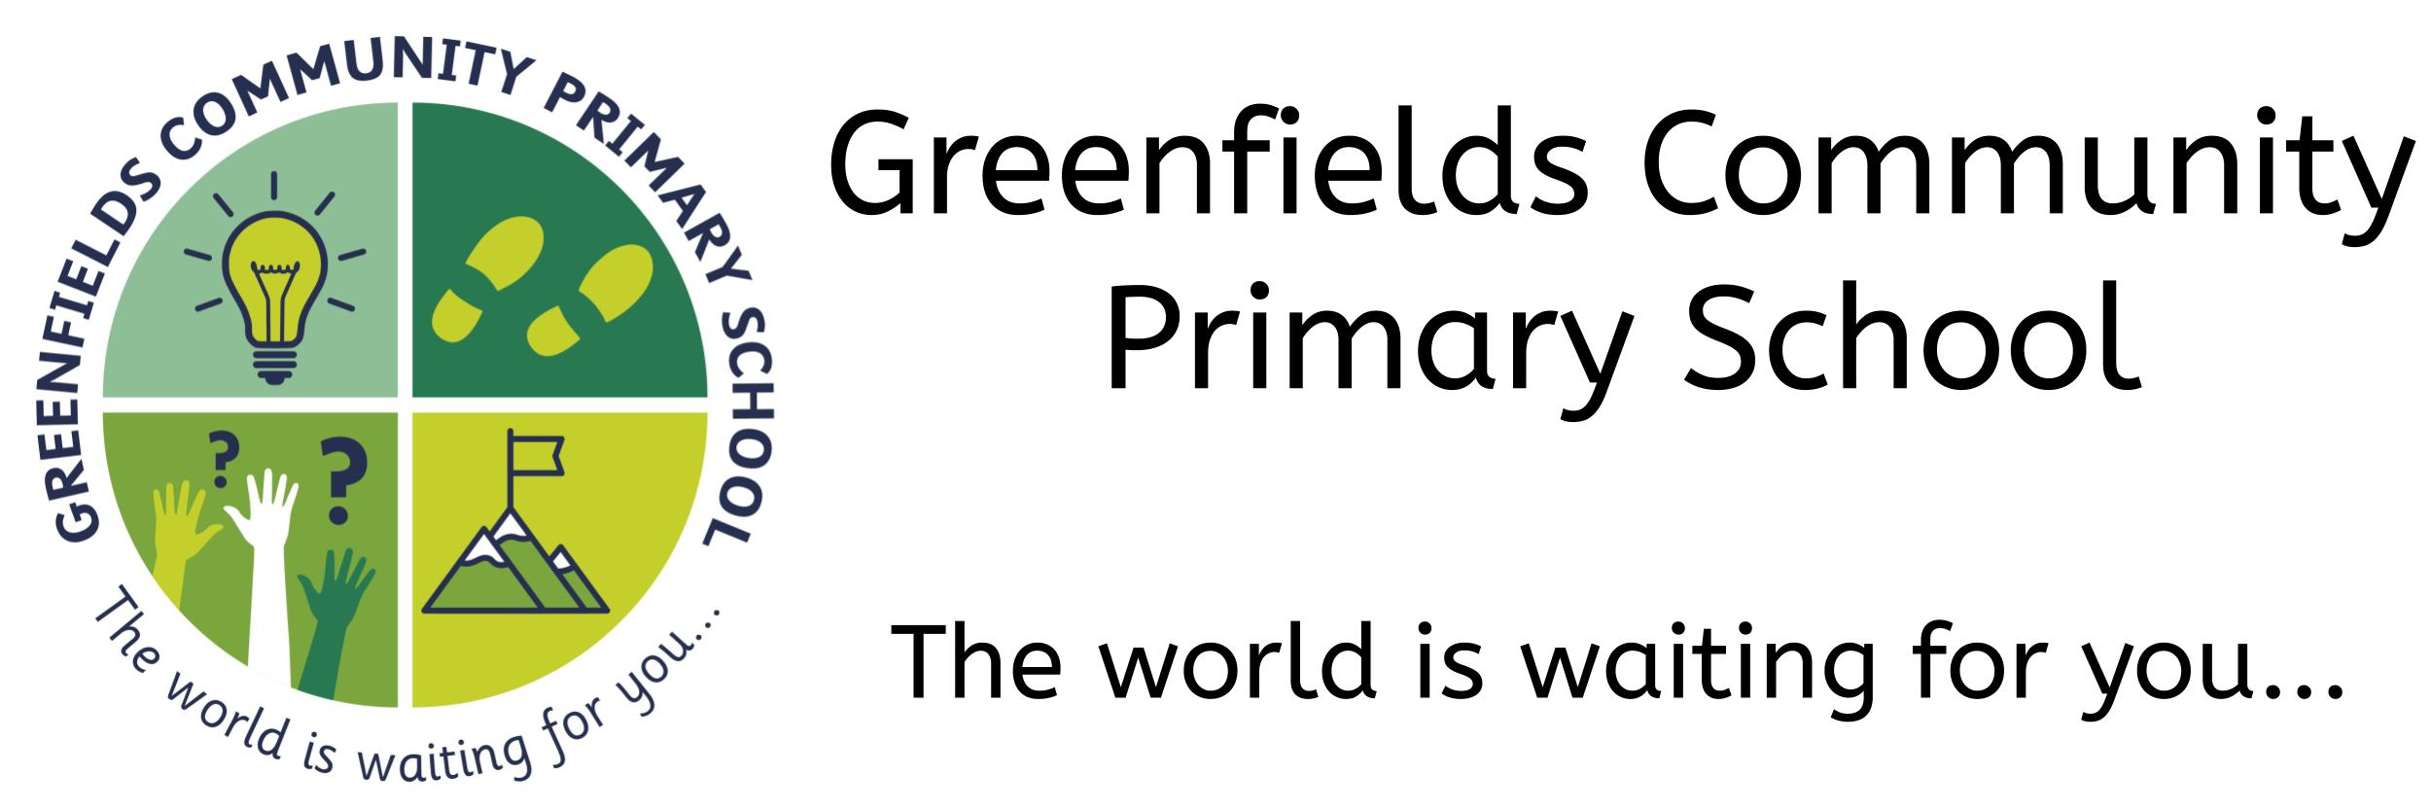  CURRICULUM OVERVIEW &  HOME LEARNING ACTIVITIES  Key Stage 2 – Year 6  Autumn 1...be amazed... | Dear Year 6 children, parents & carers,  This overview is designed to give you an idea of what we will be studying in class in each of the subjects, along with some ideas for how you could take that learning further at home. You can choose some of the activities to complete over the course of the half term or turn it into a mini-project.
As MATHEMATICIANS we will be... looking at Number, Place Value & Calculation (add, subtract, multiply & divide) At home you could:
- Practice your times tables up to 12x12
- Work out the cost of some shopping by adding it up in your head or recording your working out
- Imagine your family is going to the cinema or for a meal. Work out how much it would cost and then use your knowledge of division to work out the cost per person.
- Identify where negative numbers are used in real life. Can you find out which countries often have temperatures below zero?
As READERS & AUTHORS we will be...looking at biographies of inspirational people. At home you could:
- Think about someone who inspires you or who you would consider to be your role model. What are their main achievements and how did they ensure they were successful?
- Write a biography of your own life by writing about your life so far and what you are most proud of
As ARTISTS we will be...explaining why artists choose specific tools or techniques. At home you could:
- Find an artist who you think produces amazing pieces of art and explain why you like their work
- Look for any pieces of art around your house. Is all art the same? Why or why not?
- Find out about an artist who is from our local area
As HISTORIANS we will be...investigating why the Anglo-Saxons & Vikings invaded Britain
At home you could:
- Make your own Anglo-Saxon house with a thatched roof using card and straw
- Make your own Viking long-ship using recyclable materials such as milk bottle tops and cartons
As LINGUISTS we will be...practicing conversations in French with 3-4 exchanges. At home you could:
- Learn how to ask for items of food or drink in French… or another language if you wish!
As COMPUTER TECHNOLOGISTS we will be... learning how to be responsible digital citizens by using technology safely. At home you could:
- Identify which sites give reliable information and why
- Create an e-safety poster for younger children so they know how to stay safe online
As SPORTS SCIENTISTS we will be...participating in running and jumping activities. At home you could:
- Use Youtube or Go Noodle to do a workout from your home.
- Have a running race with someone in your family
As SCIENTISTS we will be...studying the Circulatory System in our ‘Animals including Humans’ topic. At home you could:
- Participate in exercise and identify how it affects your body - measure your heart rate before and after. How does it change? How does your breathing change?
- Measure how many breaths you take per minute. Perhaps you could compare this to someone else in your house too.
- Find out the names of the four chambers of the heart
- Draw an outline of the human body and label the organs you would find inside. Perhaps you could even do a giant diagram by drawing around someone and labelling the body parts that you already know.
As CITIZENS we will be….discussing how to get along with others. At home you could:
- Offer to do an act of kindness for a family member e.g. cleaning your room, washing the dishes or preparing part of a meal with supervision
As GEOGRAPHERS we will be...using maps and atlases to locate countries. At home you could:
- Use Google maps to locate places of interest and explain why that place is interesting to you
- Use Google Maps ‘street view’ to find the Wonders of the World. Why would they be given that name? What makes them amazing?
- Plan a route between two countries and then use a map to find the route which has the shortest distance
- Draw a map that shows the route you would take from home to school
As THEOLOGIANS we will be...learning about religious diversity in our local area. At home you could:
- See which places of worship you can see in your local area. Which religion would worship there? What are the similarities & differences between the different places of worship?

