Dear Year 6, Parents & Carers,  Here is our enquiry question for this half term. Please use these ideas to help your research or bring things into class to support your learning.  Have Fun!  Mrs Cockman, Miss Heckels  & Mrs Penfold | Upper Key Stage 2 ~ Summer II  CURRICULUM OVERVIEW  How is the Tyne Bridge strong enough to hold all the Great North Run runners? | 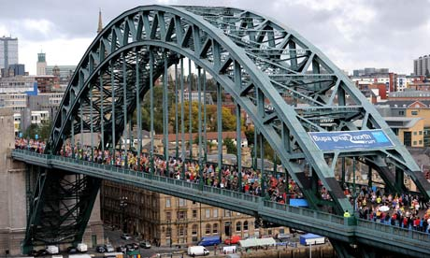
As MUSICIANS & PERFORMERS we will:  - Learn the songs from Joseph & his Technicolour Dreamcoat for our Year 6 leaver’s performance  - Choreograph dances to go alongside the chorus singing  - Act in role and ensure that we project our voices loudly and clearly  - Create scenery, sets and costumes for the performance | As Designers we will:  - Design their own bridge by convincingly justifying their plan to someone else (e.g. why they have selected specific materials or market research evidence)  - Compare bridges by talking about their features  - Use tools and materials precisely, changing the way they are working if necessary  - Explain how they have strengthened, stiffened or reinforced a complex structure, using specific shapes  - Select and use appropriate joining techniques  - Come up with a way to test and evaluate their final product  - Evaluate and improve how their mechanical systems or electrical systems work | As MATHEMATICIANS we will:  - Use precise measurements of length and weight in the construction of our bridges and the evaluation of their strength
As SCIENTISTS we will:
- Understand the forces which hold bridges up and support tunnels
- Understand mechanical systems which move the Swing bridge and the Millennium bridge
As READERS we will:  - Read ‘Inkheart’ – a metaphorical ‘bridge’ into other worlds and make inferences about the characters and their thoughts, feelings and behaviour |  | As GEOGRAPHERS we will:  - Use maps, aerial photos, plans and web to describe what a locality might be like, particularly the Quayside, and investigate the many ways of crossing the River Tyne  - Describe how some places are similar and others are different in relation to their human features  - Understand why the bridges were built and what their purpose or function is  - Recognise key symbols used on ordnance survey maps and use OS maps to answer questions
As ARTISTS we will:  - Look at the work of Jim Edwards who has produced artwork of North East landscapes and bridges  - Plan and create a piece of art that meets a given criteria  - Create a piece of art using digital images | As HISTORIANS we will:  - Summarise the main events from a specific period in history, explaining the order in which key events happened – understanding how and when the bridges were constructed across the River Tyne

